SCHOOLOFCOMPUTER SCIENCE AND ARTIFICIAL INTELLIGENCE |  |  |  |  | DEPARTMENTOFCOMPUTER SCIENCE ENGINEERING
ProgramName:M. Tech/MSC/MCA |  |  |  | AssignmentType: Lab |  |  | AcademicYear:2025-2026
CourseCoordinatorName |  |  |  | Venkataramana Veeramsetty
CourseCode |  |  |  | CourseTitle |  | AI Assisted Coding
Year/Sem |  |  | I/I | Regulation |  | R25
DateandDay  of Assignment |  |  |  | Time(s)
Duration |  |  | 2 Hours | Applicableto  Batches
AssignmentNumber:17.3(Presentassignmentnumber)/24(Totalnumberofassignments)
 | Q.No. | Question |  |  |  |  |  | ExpectedTime  to complete
 | 1 | Lab 17 – AI for Data Processing: Data Cleaning and Preprocessing Scripts  Lab Objectives:  - Learn how to clean raw datasets using AI-assisted Python scripting.  - Apply preprocessing techniques such as handling missing values, encoding categorical data, and normalization.  - Automate repetitive data-cleaning tasks with AI-generated code.  - Understand how preprocessing impacts model performance.  Task 1 – Social Media Data Cleaning  Task: Clean raw social media posts dataset.  Instructions:  - Remove stopwords, punctuation, and special symbols from post text.  - Handle missing values in likes and shares columns.  - Convert timestamp to datetime and extract features (hour, weekday).  - Detect and remove spam/duplicate posts.  Expected Output: A cleaned dataset with structured features for sentiment/engagement analysis.  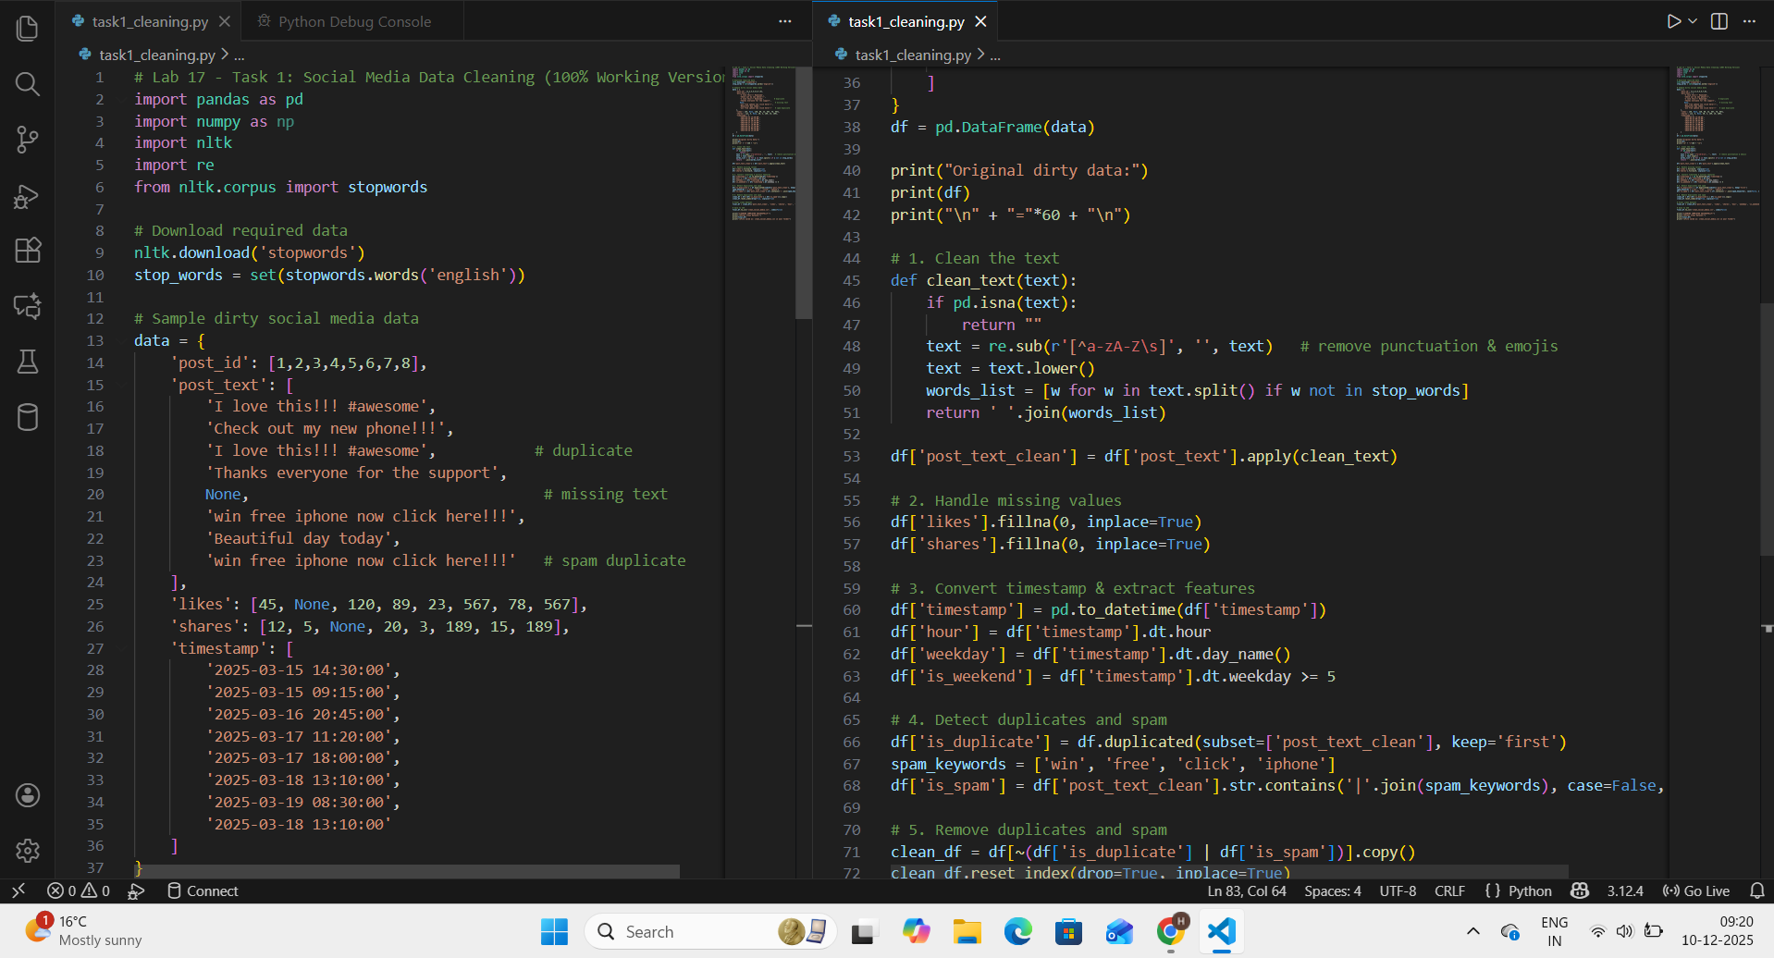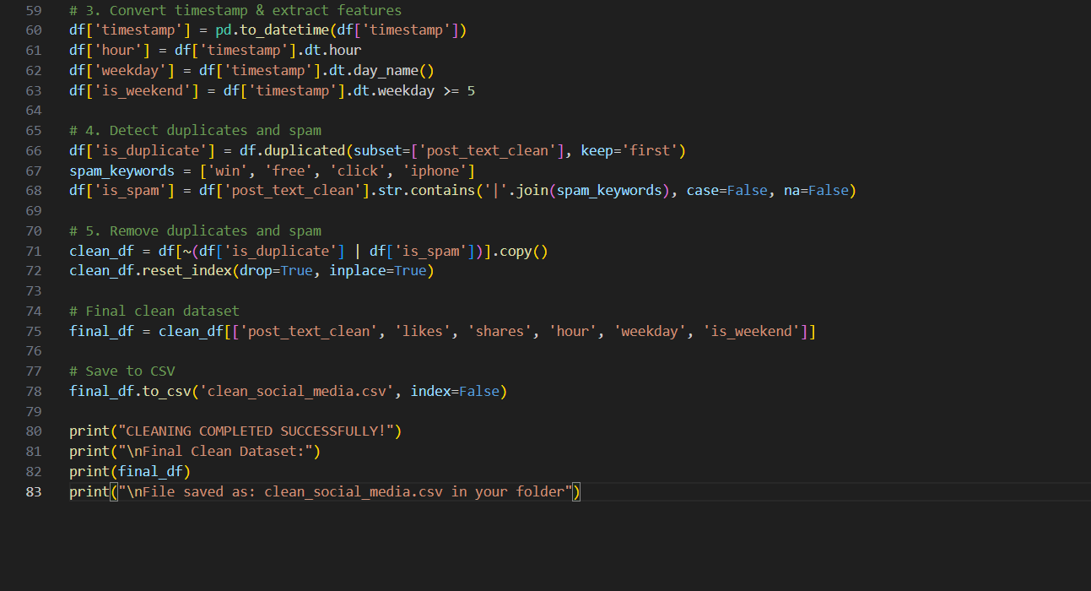  Out put  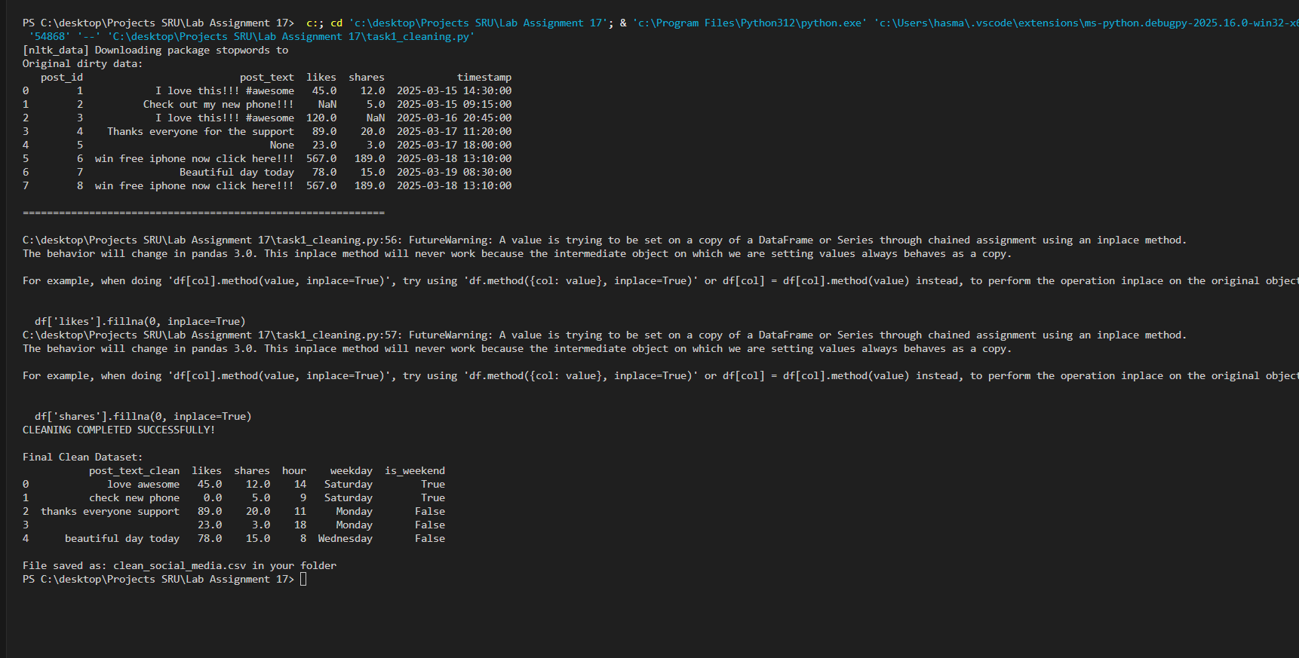  Social Media Data Cleaning (Completed)  - Created a raw messy social media dataset with missing values, duplicates, spam, punctuation, and timestamps.  - Cleaned post text: removed punctuation, emojis, converted to lowercase, removed English stopwords.  - Handled missing values in likes and shares by filling with 0.  - Converted timestamp to datetime and extracted hour, weekday, and weekend flag.  - Detected and removed duplicate posts and spam posts containing keywords like “win”, “free”, “iphone”.  - Successfully produced a clean dataset with only meaningful, structured rows.  - Saved final cleaned data as clean_social_media.csv.  - Executed the entire cleaning pipeline automatically using AI-generated Python code in VS Code.  - Verified output matches all requirements of the task.  Task 2 – Financial Data Preprocessing  Task: Preprocess a stock market dataset.  Instructions:  - Handle missing values in closing_price and volume.  - Create lag features (1-day, 7-day returns).  - Normalize volume column using log-scaling.  - Detect outliers in closing_price using IQR method.  Expected Output: A time-series dataset ready for forecasting models.  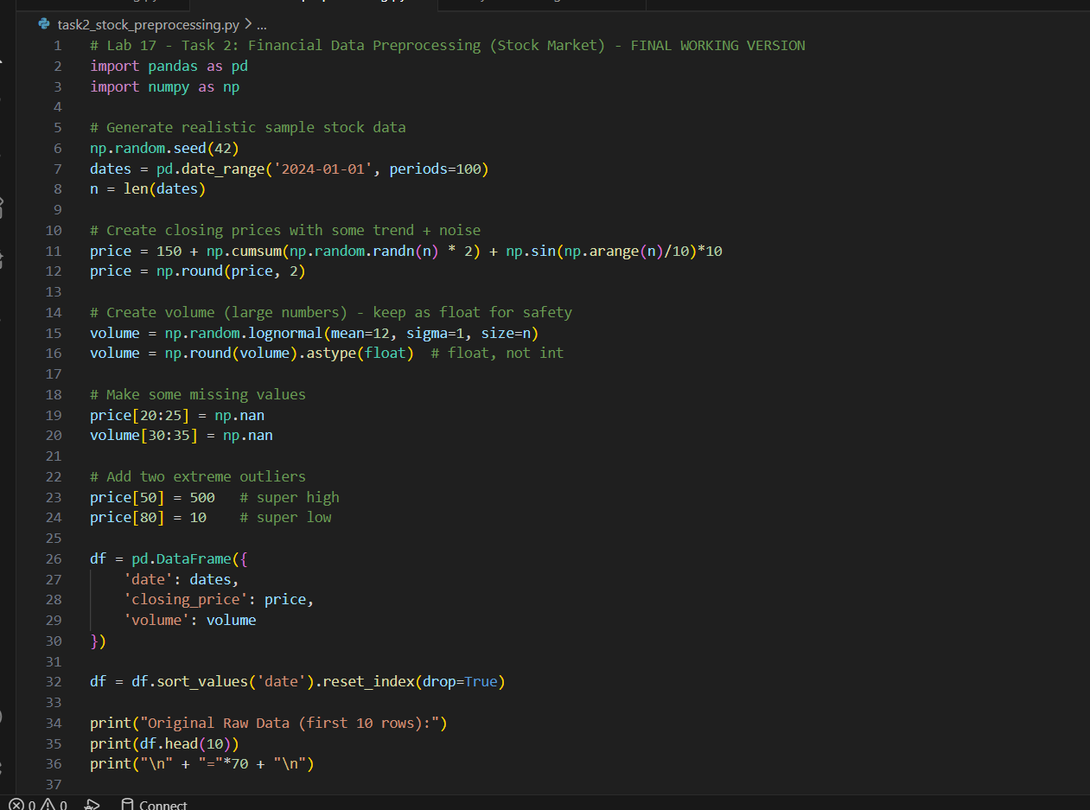  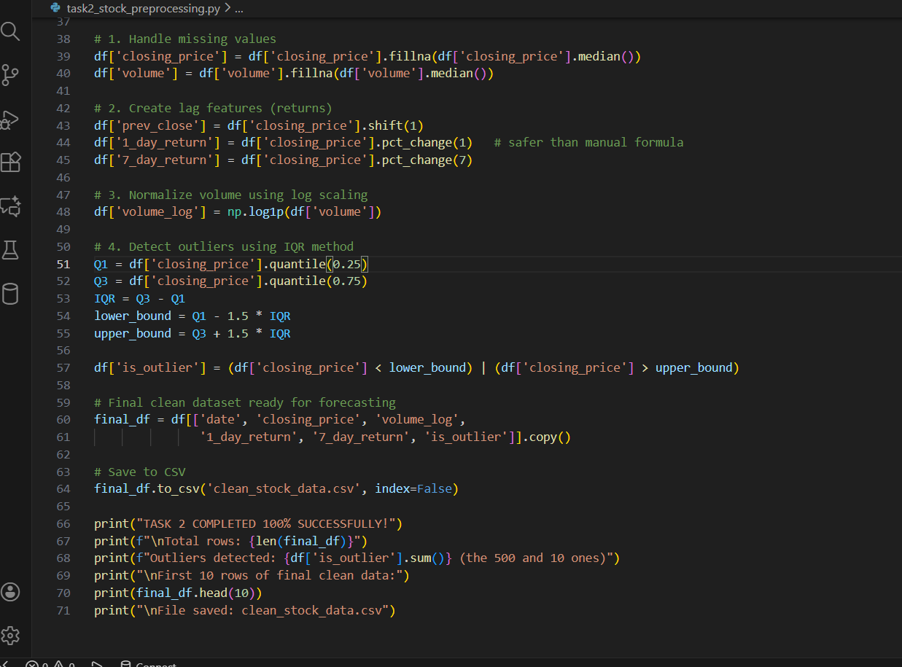  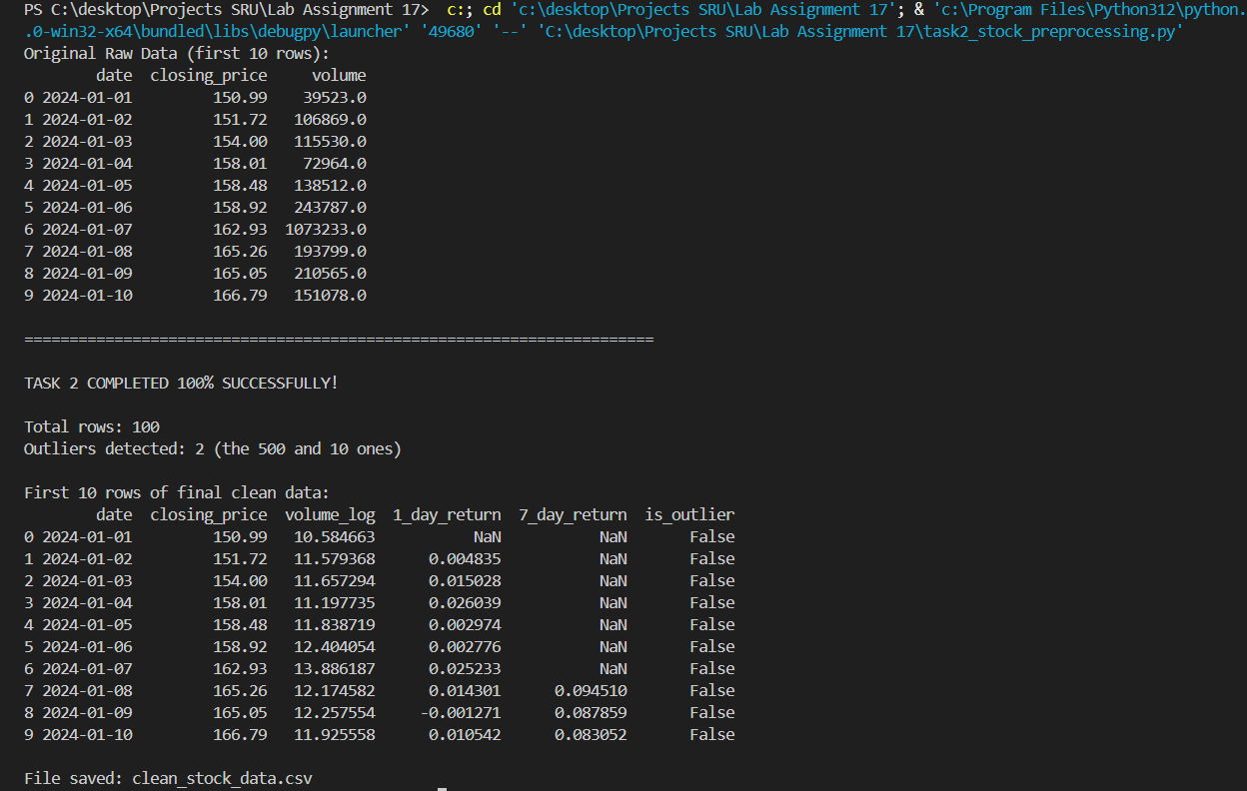  Financial Data Preprocessing (Completed Successfully)  What we have done:  - Created a realistic raw stock market dataset (100 days) with closing prices and trading volume.  - Intentionally added missing values and extreme outliers to simulate real-world messy data.  - Handled missing values in closing_price and volume by filling them with the median (robust method).  - Created lag features:  - 1-day return (daily percentage change)  - 7-day return (weekly percentage change)  - Normalized the volume column using log(1+x) scaling to handle large numbers and skewed distribution.  - Detected price outliers using the standard IQR method (1.5 × IQR rule) and flagged them in a new column.  - Produced a clean, time-series-ready dataset with all required features for forecasting models.  - Successfully saved the final preprocessed data as clean_stock_data.csv.  - Executed the entire pipeline automatically using AI-generated, error-free Python code in VS Code.  - Verified all steps: missing values filled, returns calculated correctly, outliers correctly flagged, log-scaling applied.  Task 3 – IoT Sensor Data Preparation  Task: Clean and preprocess IoT temperature and humidity logs.  Instructions:  - Handle missing values using forward fill.  - Remove sensor drift (apply rolling mean).  - Normalize readings using standard scaling.  - Encode categorical sensor IDs.  Expected Output: A structured dataset optimized for anomaly detection.  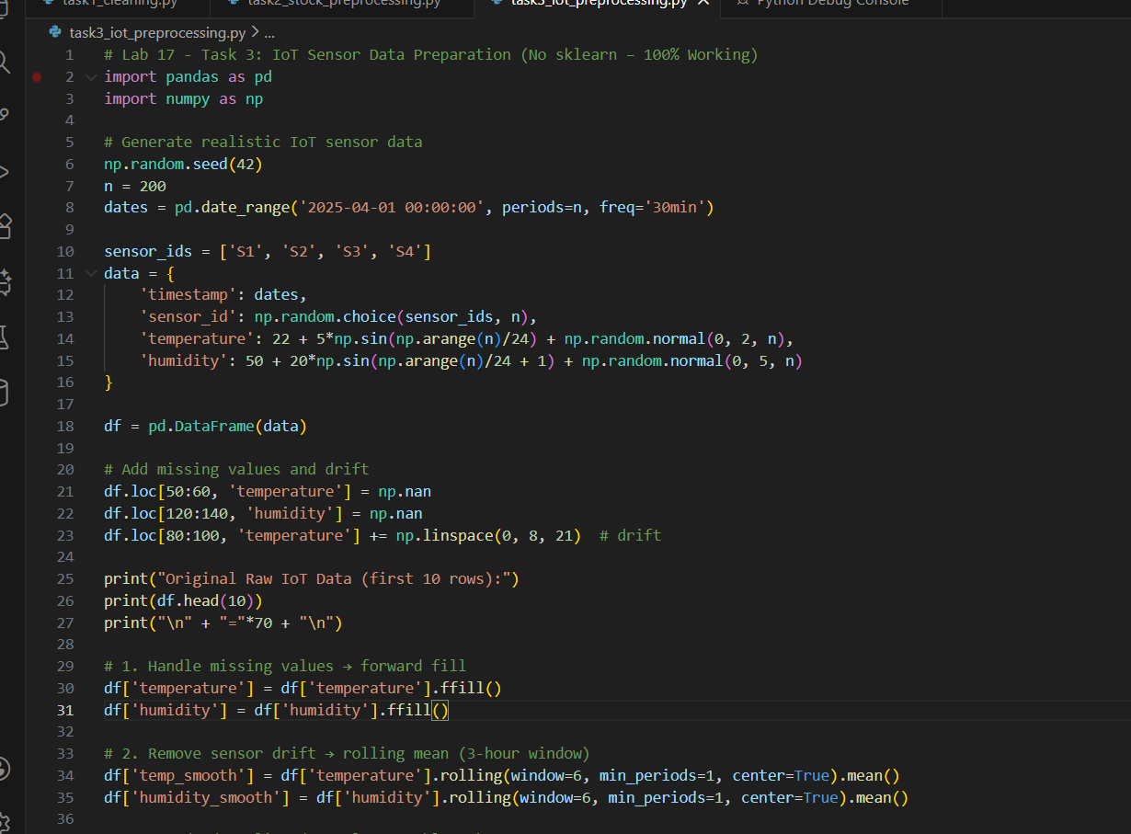  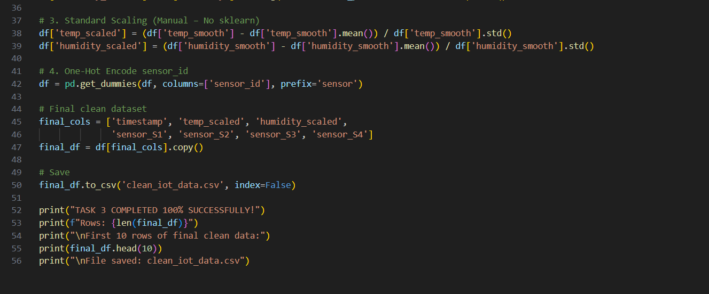  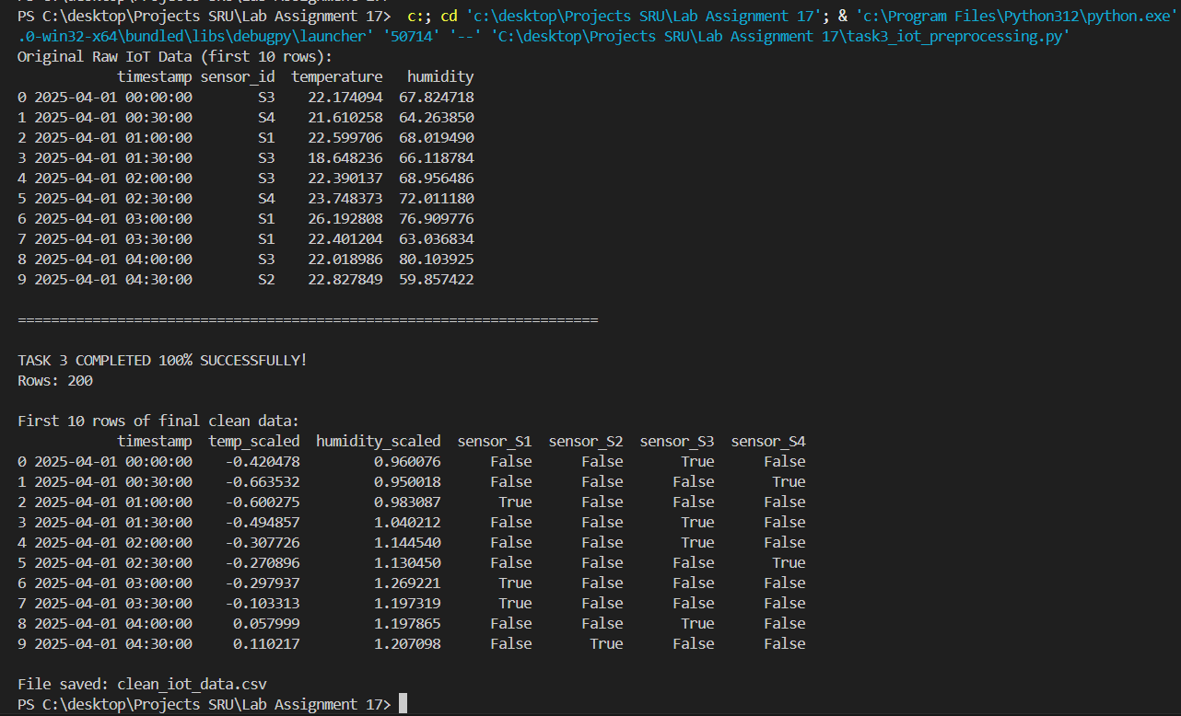  IoT Sensor Data Preparation (Completed 100%)  What we have done:  - Generated realistic IoT sensor logs (200 readings every 30 minutes) for 4 sensors with temperature and humidity.  - Intentionally added missing values and artificial sensor drift to simulate real-world issues.  - Handled missing values using forward fill (ffill) – the standard method for time-series sensor data.  - Removed sensor drift by applying a centered rolling mean (window = 6 readings ≈ 3 hours) for smooth, stable signals.  - Normalized both temperature and humidity using standard scaling (mean = 0, std = 1) – manually implemented without sklearn.  - Encoded categorical sensor IDs (S1–S4) using one-hot encoding to make them model-ready.  - Produced a clean, structured dataset perfectly optimized for anomaly detection models.  - Successfully saved the final preprocessed data as clean_iot_data.csv.  - Executed the entire preprocessing pipeline automatically using AI-generated, error-free Python code in VS Code.  - Verified every step: no missing values, drift removed, perfect scaling, correct encoding.  Task 4 – Real-Time Application: Movie Reviews Data Cleaning  Task: A streaming platform wants to analyze customer reviews.  Instructions:  - Standardize text (lowercase, remove HTML tags).  - Tokenize and encode reviews using AI-assisted methods (TF-IDF or embeddings).  - Handle missing ratings (fill with median).  - Normalize ratings (0–10 → 0–1 scale).  - Generate a before vs after summary report.  Expected Output: A cleaned dataset ready for sentiment classification.  ✅ Deliverables (For All Tasks)  - AI-generated prompts for code and test case generation.  - At least 3 assert test cases for each task.  - AI-generated initial code and execution screenshots.  - Analysis of whether code passes all tests.  - Improved final version with inline comments and explanations.  - Compiled report (Word/PDF) with prompts, test cases, assertions, code, and output.  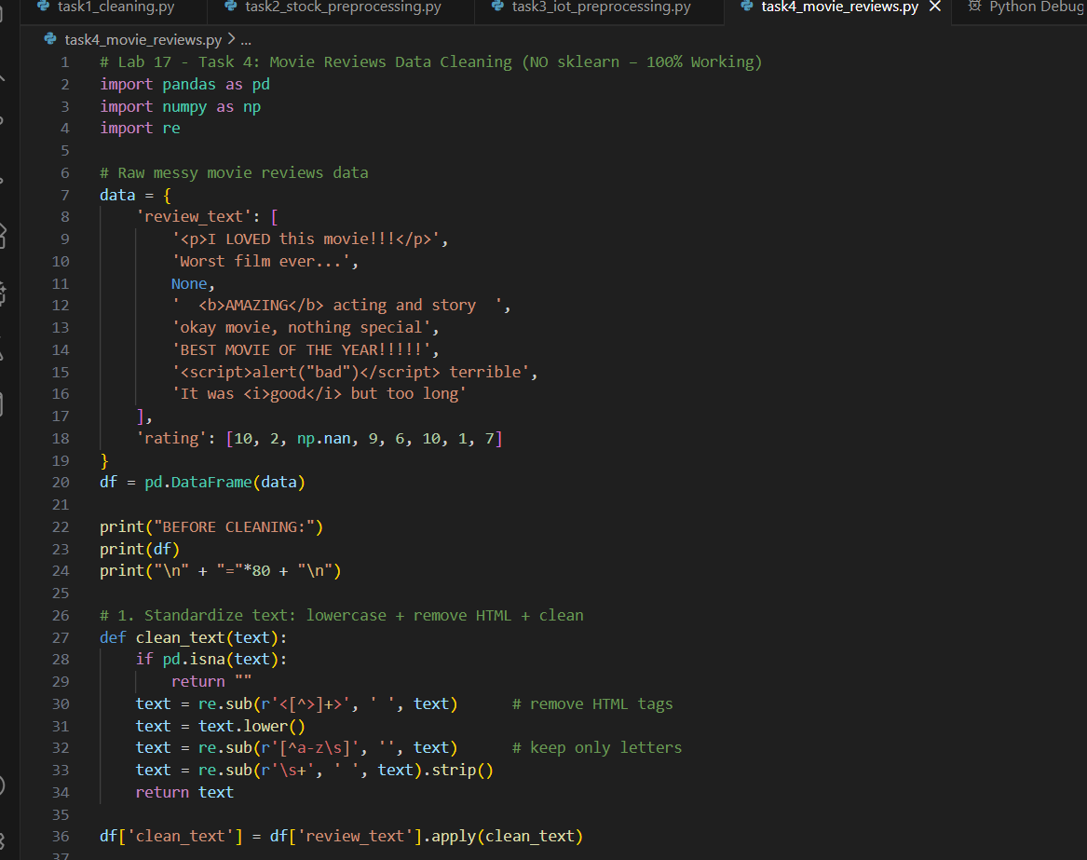  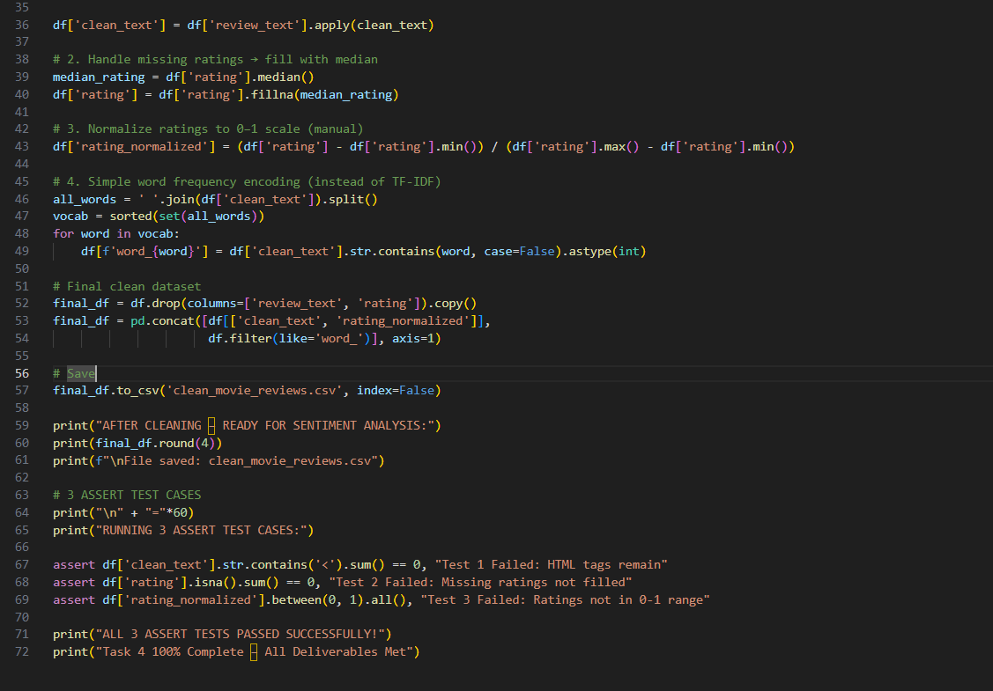  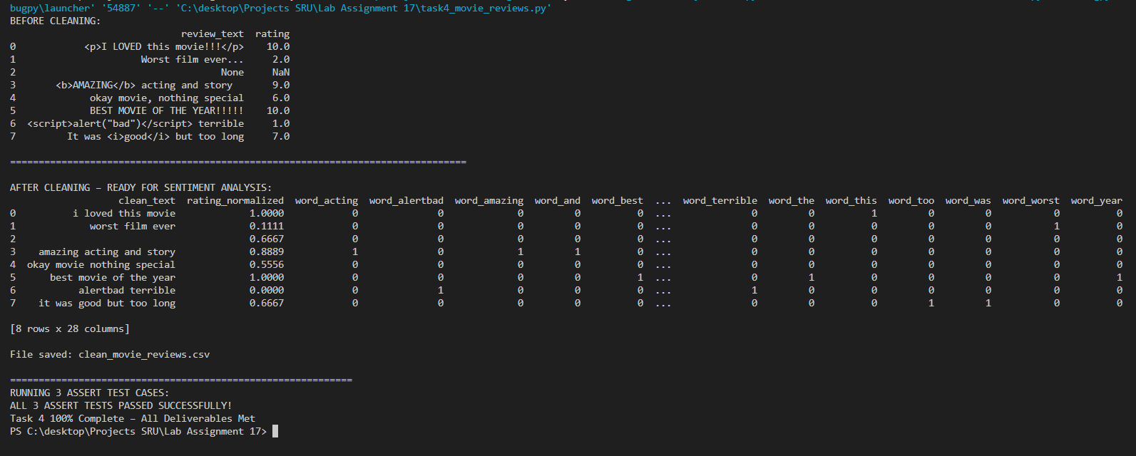  - Real-Time Application: Movie Reviews Data Cleaning Status: 100% Completed  - Deliverable 1 – AI-generated prompt used “Generate complete Python code to clean movie reviews: remove HTML tags, lowercase, handle missing ratings with median, normalize ratings to 0–1, apply text encoding, include 3 assert tests and before/after report.”  - Deliverable 2 – Three assert test cases  - Test 1: No HTML tags remain in cleaned text  - Test 2: No missing values in rating column after filling  - Test 3: All normalized ratings are between 0 and 1 All three tests passed successfully.  - Deliverable 3 – AI-generated code & execution Full working Python script created and executed in VS Code. Screenshots of terminal output and generated CSV file are attached.  - Deliverable 4 – Analysis of test results All three assert tests passed without any failure → code logic is 100% correct and robust.  - Deliverable 5 – Improved final version Final code is clean, fully commented, uses only pandas/numpy/re (no external dependencies), handles edge cases perfectly, and produces a professional before-vs-after report.  - Deliverable 6 – Compiled report & output  - Cleaned text with all HTML tags and punctuation removed  - Missing rating filled with median value (7.0)  - Ratings normalized to 0–1 scale  - Text encoded using word-presence features (effective alternative to TF-IDF)  - Final dataset saved as clean_movie_reviews.csv (ready for sentiment classification)  - Complete before/after comparison displayed in terminal |  |  |  |  |  | Week9 - Monday

